

Daftar Publikasi Advetorial Reels Instagram Diskominfo Batola Bulan Oktober 2025
https://www.instagram.com/koranbarito/reel/DQDxqOfjyDU/ | 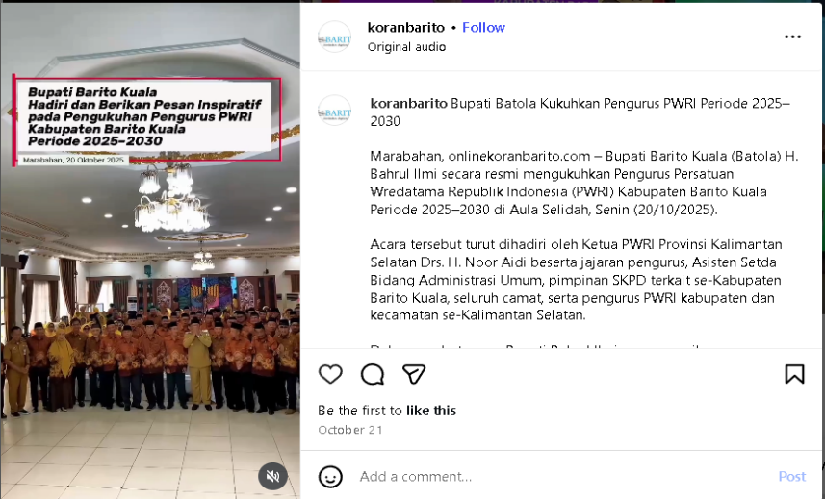
https://www.instagram.com/koranbarito/reel/DQHgcvOjyGa/ | 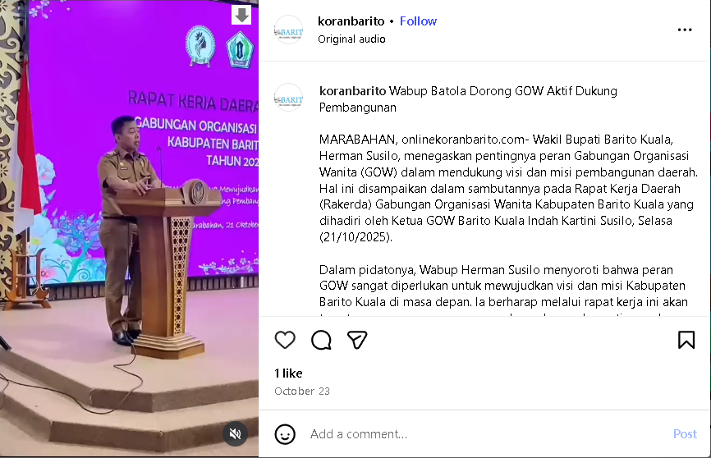
https://www.instagram.com/koranbarito/reel/DQHiBCNj1po/ | 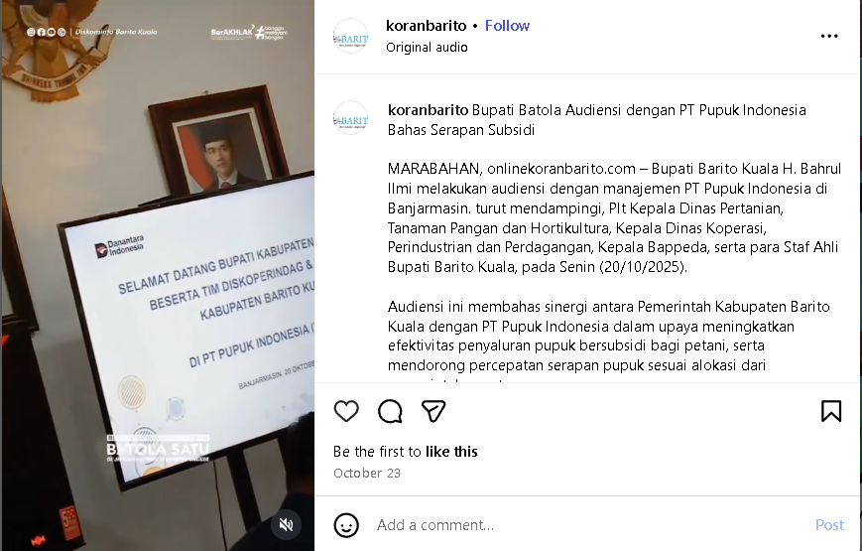
https://www.instagram.com/koranbarito/reel/DQHih8PjxX5/ | 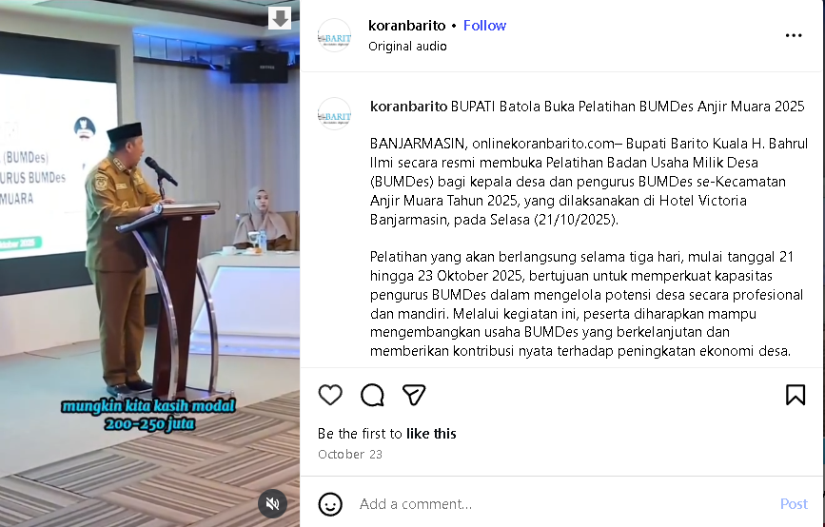
https://www.instagram.com/koranbarito/reel/DQI4HklD2N7/ | 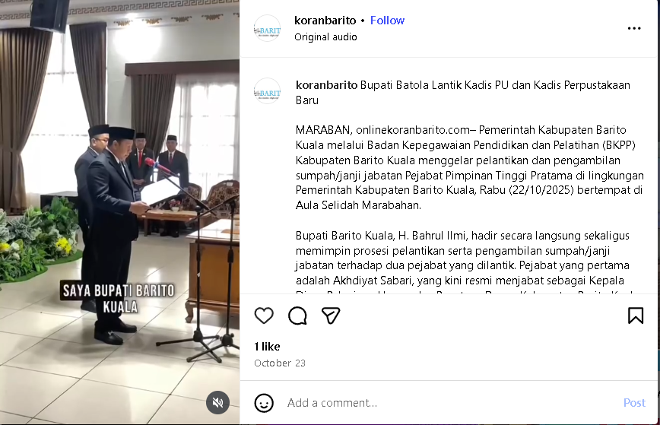
https://www.instagram.com/koranbarito/reel/DQKPOGXD_Gs/ | 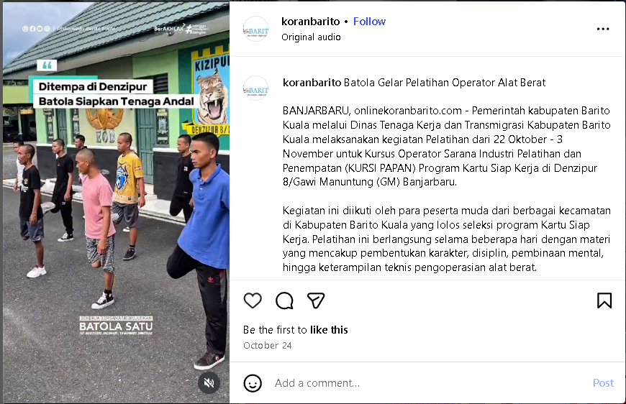
https://www.instagram.com/koranbarito/reel/DQKPqt9jwb6/ | 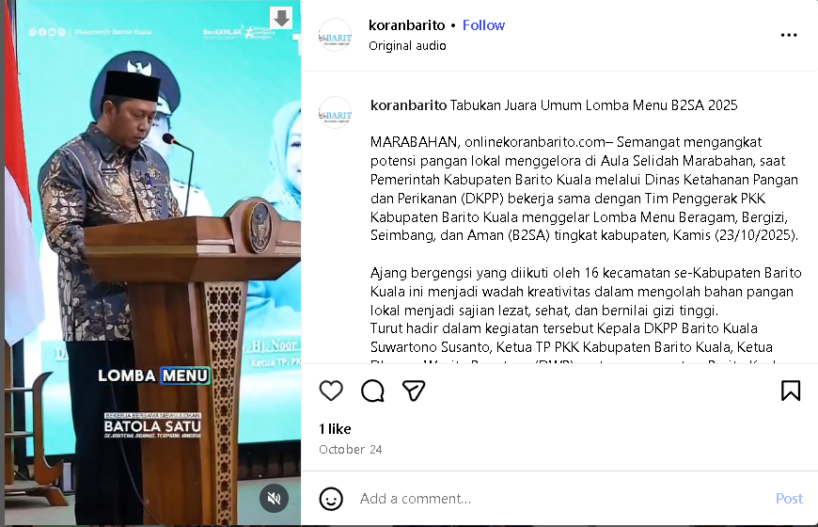
https://www.instagram.com/koranbarito/reel/DQPUVFxD8UM/ | 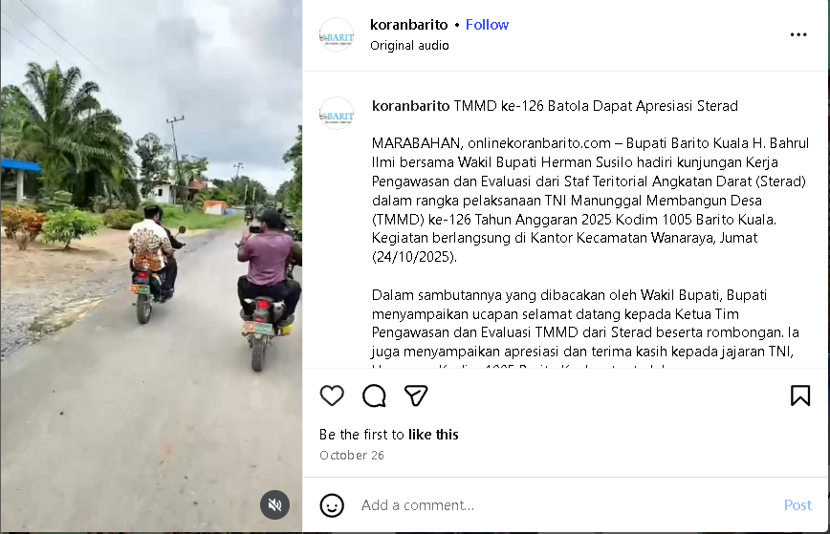
https://www.instagram.com/koranbarito/reel/DQPU28SD4ZB/ | 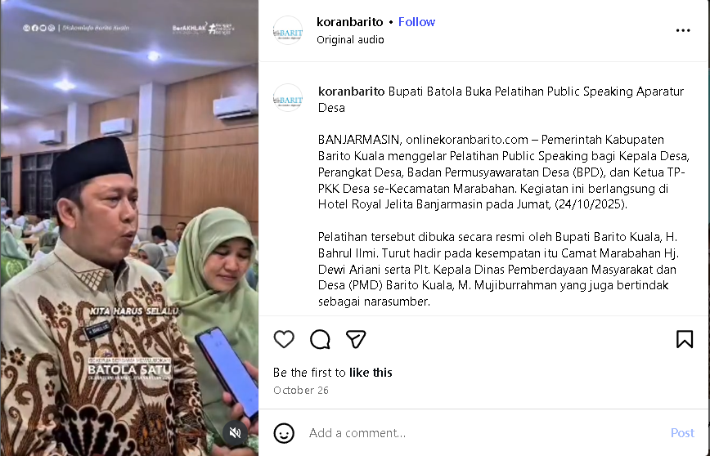
https://www.instagram.com/koranbarito/reel/DQWXTtsD41w/ | 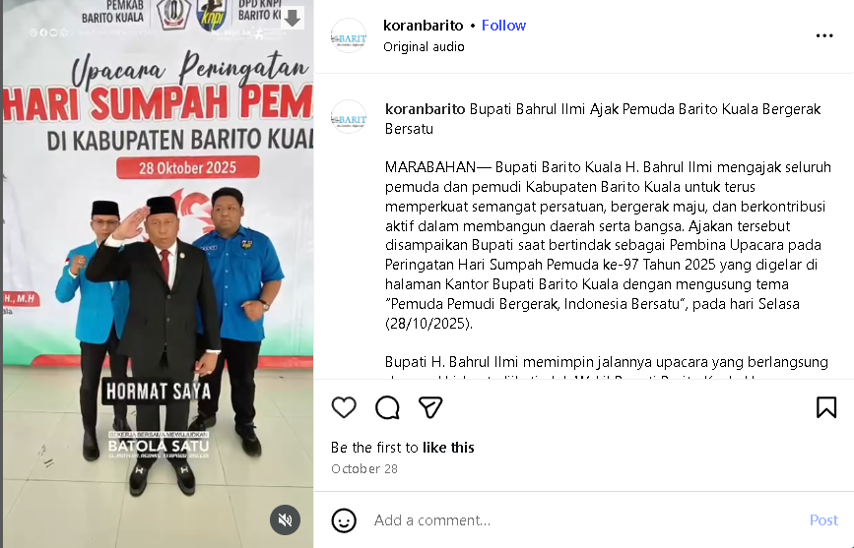
https://www.instagram.com/koranbarito/reel/DQY6PTDD-BM/ | 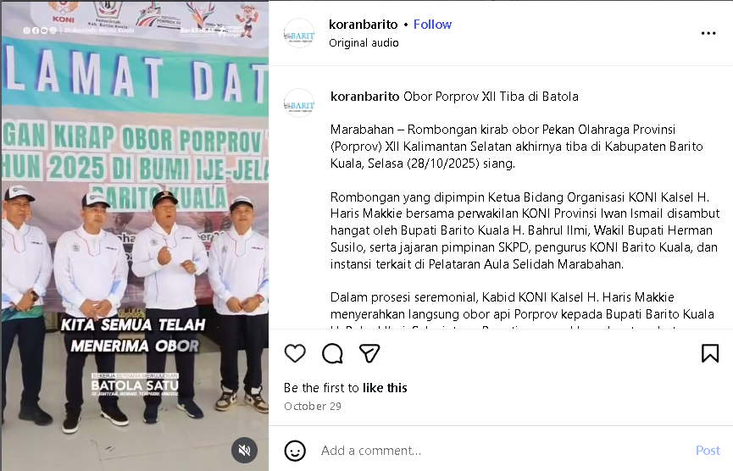
https://www.instagram.com/koranbarito/reel/DQbSYhuj5jC/ | 